Project Value Statement

By initiating this hand hygiene project in hospitals and various health care centers, it provides a lot of value in the form of service to the patients. By implementing this project successfully, the number of diseases those were spreading now due to lack of hand hygiene will decrease and any hospital implement this according to the strategies, they will achieve 100% hand hygiene compliance in the next 8 months which is October 2016.

Project Methodology.

The project management method we use for this hand hygiene project is Agile Methodology. Agile methodology is an alternative to traditional project management, typically used in software development. It helps teams respond to unpredictability through incremental, iterative work cadences, known as sprints.

The Phases of Agile methodology are as follows:
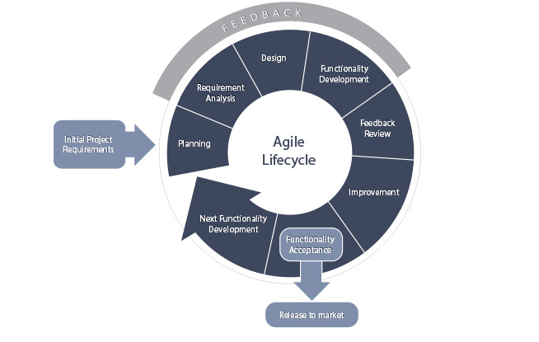

This is most commonly used in software development but the approach can also be powerful in some other types of projects as well. Some users say that practitioners must have lightweight project management processes in place in order to deliver in the short timeframes that Agile demands. Instead of building the project all together, the development is broken up into sprints with small deliverables.

- Initiation Phase: In the initiation phase, we gather all the business and user requirements to complete this project by conducting some surveys and evaluating previous records of health diseases those were caused due to lack of hand hygiene.

- Planning Phase: Here, after gathering requirements, the managers will think about the budget and schedule and how long the project may prolong and everything was documented with time and cost and will be handed over to the hospital management.

- Requirement Analysis: When the project is initiated and planned, the next thing that should be focused is analyzing the available requirements for the project. For example, we need some computer equipment and database specialists in this project, so we have to mention them as requirements for this project and make sure that they are available for the next phase.

- Design: Here necessary tasks are assigned to the designated personal and the project will be designed and it will be followed by the entire project team. If any changes are done here, it shows a little difference in the next upcoming phases.

- Functionality Development and Feedback: This is a little critical phase because the amount of work that needed to be done here is very vast and complex. It is important that the project needs to be developed day by day with necessary user requirements and the manager should get some important feedback based on the current design. It enables the manager and the employees to make necessary changes in the project.

- Improvement: Based on the feedback from the employees within the organization about how the project is going to be, making necessary changes is mandatory as it is a part of the project. It could be like increasing the equipment cost or hiring more people for convenience.

- Functionality Acceptance: After everything is done, the project will be implemented and released in the given cost and schedule.

- Next Functionality Development: In case the next cycle of the project needs to be developed or the same project with different constraints, using these strategies and methods, that can be implemented with ease.

